📌 Job Tracking Application
Selected Model: Role-Based Recruitment Marketplace Platform
This system connects Companies (Recruiters) and Students (Job Seekers) with Admin controlling the platform.

✅ STEP 2: Identify User Roles
Role | Description | Access Level
Admin | Manages entire platform | Full system access
Company | Posts jobs & manages applicants | Company-level access
Student | Applies for jobs & tracks status | Limited access

✅ STEP 3: Functional Requirements
🔐 Authentication & Authorization
- User registration
- Login with JWT authentication
- Role-based access control
👥 User Management
- Separate profiles for Students & Companies
- Profile update functionality
💼 Job Management
- Create, update, delete jobs
- View job listings
- Search & filter jobs
📄 Application Management
- Apply to job
- Resume upload support
- View applicants (Company side)
- Update application status
- Track status (Student side)
📊 Dashboard
- Company: Total jobs, applicants count
- Student: Total applications, status breakdown

👤 User Management
- User registration (Student / Company)
- Login with JWT authentication
- Role-based access control
- Profile management
- Resume upload (Student)
- Company profile management

💼 Job Management (Company Side)
- Create job posting
- Update job details
- Delete job
- View posted jobs
- Search & filter jobs
- View applicants for specific job
- Update application status

📄 Application Management
- Apply to job
- Prevent duplicate application
- Store application with default status = Pending
- Track application status
- View application history

📊 Dashboard
👨‍💼 Company Dashboard
- Total jobs posted
- Total applicants
- Application status breakdown
🎓 Student Dashboard
- Total applications
- Status overview:
  - Pending
  - Shortlisted
  - Rejected
  - Selected

👨‍💻 Admin Controls
- View total users
- View total companies
- View total jobs
- View total applications
- Block / Unblock users
- Monitor system activity

✅ STEP 4: Non-Functional Requirements
(Defines HOW system should perform)
• Secure authentication using JWT
• Optimized database queries
• Scalable architecture
• Clean API structure
• Proper error handling
• Logging support
• Maintainable code structure

🔐 Security
- JWT-based authentication
- Password encryption using BCrypt
- Role-based authorization
- Secure file upload handling

⚡ Performance
- API response time < 2 seconds
- Pagination for job listings
- Optimized database queries

📈 Scalability
- Designed to support multiple companies
- Database indexing on:
  - email
  - jobId
  - studentId
- Modular architecture for future expansion

🔄 Reliability
- Proper exception handling
- Transaction consistency
- Logging support

📝 Maintainability
- Layered architecture
- Clean API structure
- Separation of concerns
- Reusable service layer

✅ STEP 5: High-Level Architecture
🎯 Architecture Type: Monolithic REST-Based Architecture
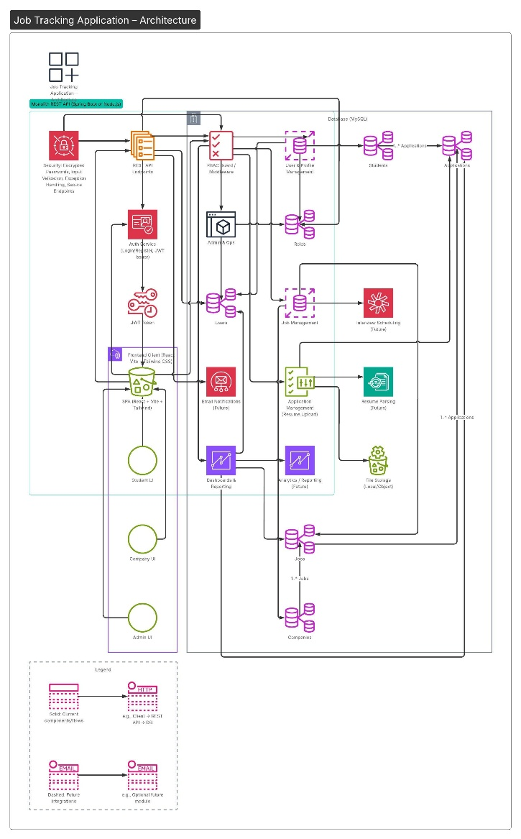

🏗 System Flow
Client (React + Vite + Tailwind)
⬇
REST API (Node.js / Spring Boot)
⬇
Database (MySQL / MongoDB)

✅ STEP 6: Basic ER Design (Entities)
Core Entities:
- Users
- Roles
- Students
- Companies
- Jobs
- Applications
- Resumes
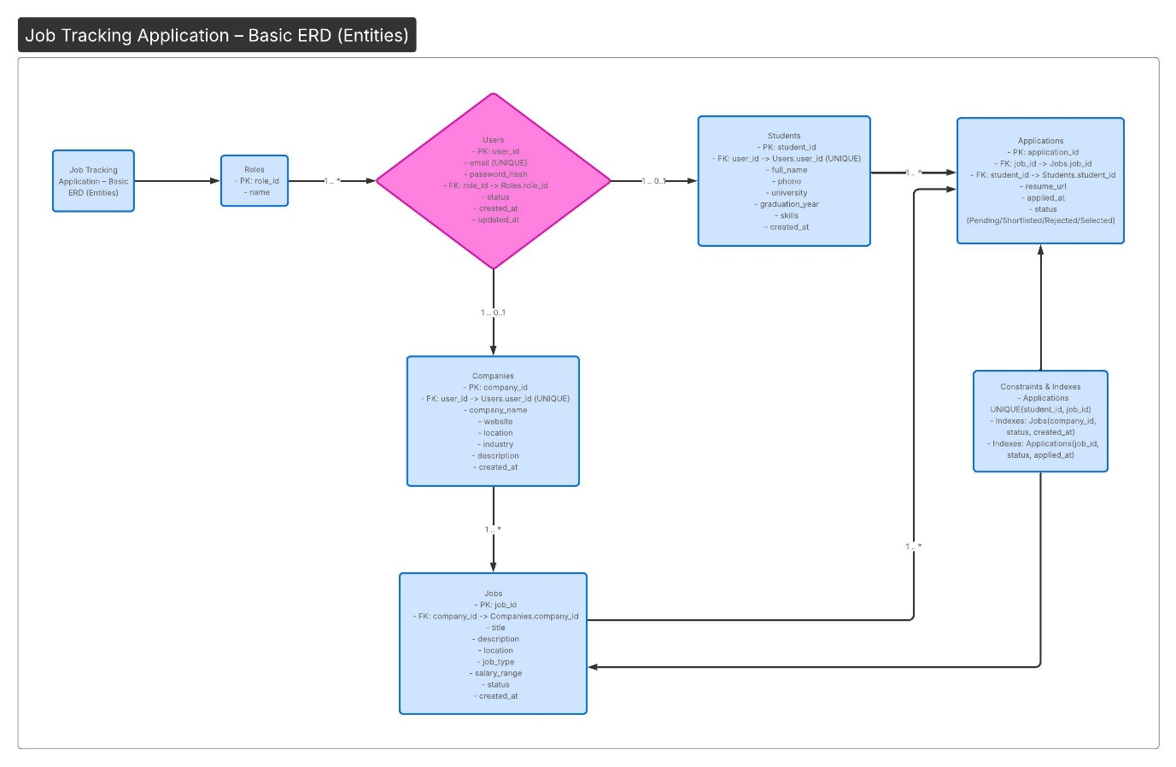

Key Relationships:
- One Company → Many Jobs
- One Job → Many Applications
- One Student → Many Applications

✅ STEP 7: Core Module Design – Job Tracking Application

🔐 1. Authentication & Authorization Module
📌 Purpose
Secure system access using JWT and role-based authorization.
⚙ Responsibilities
- Register user
- Login user
- Generate JWT token
- Validate JWT
- Encrypt password (BCrypt)
- Role verification (Admin / Company / Student)
🔄 Flow
- User submits login credentials
- System validates credentials
- JWT token generated
- Token required for all secured APIs
- Access granted based on role
📊 Importance
- Protects sensitive recruitment data
- Prevents unauthorized job manipulation
- Ensures secure system access

👤 2. User Management Module
📌 Purpose
Manage user profiles separately from authentication.
⚙ Responsibilities
- Update profile
- Upload resume
- Change password
- Manage company details
- Admin user control
🏗 Design Principle
Separated from authentication for clean architecture.

💼 3. Job Management Module
📌 Purpose
Handle complete job lifecycle.
⚙ Responsibilities
- Create job
- Update job
- Delete job
- Search jobs
- Filter jobs
- View applicants
🔄 Job Lifecycle
CREATED → ACTIVE → CLOSED

📄 4. Application Management Module
📌 Purpose
Handle student job applications.
⚙ Responsibilities
- Apply to job
- Validate duplicate applications
- Store status (Pending)
- Update status:
  - Pending
  - Shortlisted
  - Rejected
  - Selected
- Track status (Student side)
🔄 Application Lifecycle
APPLIED → SHORTLISTED → SELECTED / REJECTED
This module contains core recruitment logic.

📁 5. Resume Upload Module
📌 Purpose
Allow students to upload resume securely.
⚙ Responsibilities
- Upload resume file
- Store file reference in DB
- Validate file type (PDF/DOC)
- Secure file access

📊 6. Dashboard & Reporting Module
📌 Purpose
Provide analytics and system visibility.
⚙ Responsibilities
- Count jobs
- Count applications
- Status breakdown
- Admin analytics view

🏗 7. Internal Layered Architecture
Each module follows layered structure:
Controller Layer → Handles HTTP requests
Service Layer → Business logic
Repository Layer → Database interaction
Entity Layer → DB tables
DTO Layer → Data transfer objects

🎯 Design Benefits
✅ Clear separation of responsibilities
✅ Easy debugging
✅ Scalable design
✅ Clean architecture
✅ Secure role-based access
✅ Future microservices migration possible
✅ Production-ready structure

